Electric Vehicle Charging
Pre-Survey Form
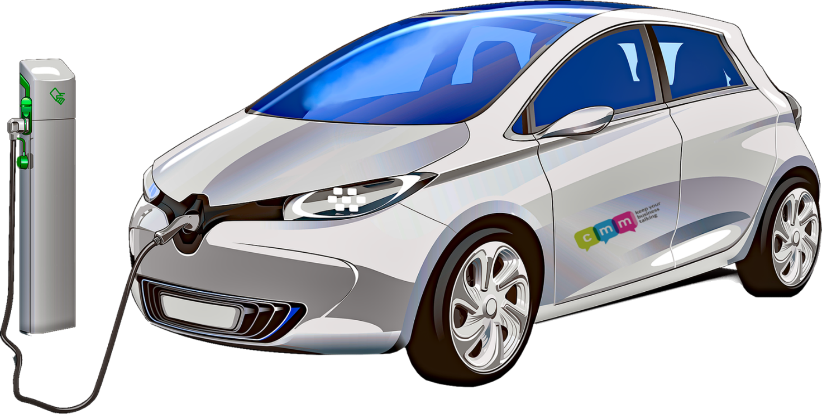

Once you have completed this form, please send it to:

info@cmmenergy.co.uk

Company name
Point of contact/position
Address

Phone number
Email
Type of EV Unit | WallPod/ Pedestal
How many charge points
Speed of chargers and quantity | 3.6 kWh/ 7.2 kWh / 11 kWh / 22 kWh / 50 kWh / 100 kWh / 150 kWh
Do you want to charge money to users? | Yes/No
Type of installation ground | Soft – Hard - Concrete
WCS grant funded? | Yes - No
How many wires going from Meter to Fuse Board? | Single Phase or Three Phase  1 or 3 Wires
Length of run from fuse board to EV points?
Pictures of Run | Required
Picture of Fuse Board | Required
Pictures of where charging units are to be installed | Required

With the above information, a quote will be produced. Every single EV charging install is bespoke, due to civil and electric works required to run the cabling and securing the charge points.

We also need to review the fuse board along with the electric meter type to see what level of chargers are available.

All our quotes are based upon the information given above. Any further works that are not listed in the quotation will be deemed as extra and therefore chargeable. No further works will be carried out until discussed and a price agreed.

If more information is required, we will give you a call!

